Experiment no-18
Agri Mart – Online Agricultural Shopping
AIM:
To develop an online agricultural shopping website for searching and selecting farming products.
PROCEDURE:
- Create a webpage with agricultural product categories.
- Display product names and prices.
- Allow users to select products.
- Display the selected product and its price.
Sample Code:

<!DOCTYPE html>
<html>
<head><title>AgriMart</title></head>
<body>
<h2>AgriMart</h2>
<select id="product">
<option value="500">Seeds - ₹500</option>
<option value="800">Fertilizer - ₹800</option>
<option value="1200">Farming Tools - ₹1200</option>
</select>
<button onclick="order()">Order Product</button>
<p id="out"></p>
<script>
function order() {
let p = document.getElementById("product");
document.getElementById("out").innerText =
"Selected: " + p.options[p.selectedIndex].text;
}
</script>
</body>
</html>
Sample Output:
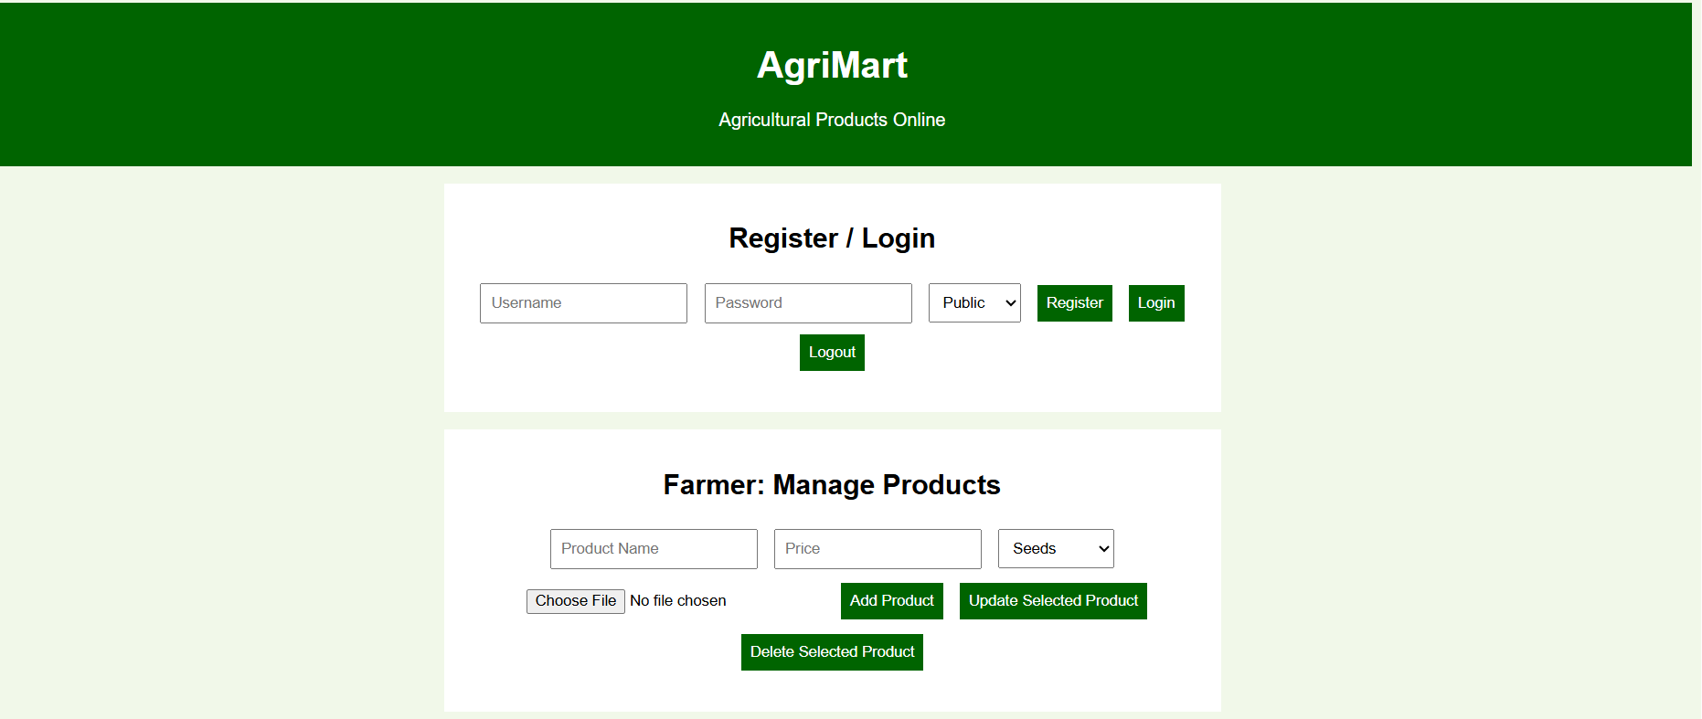
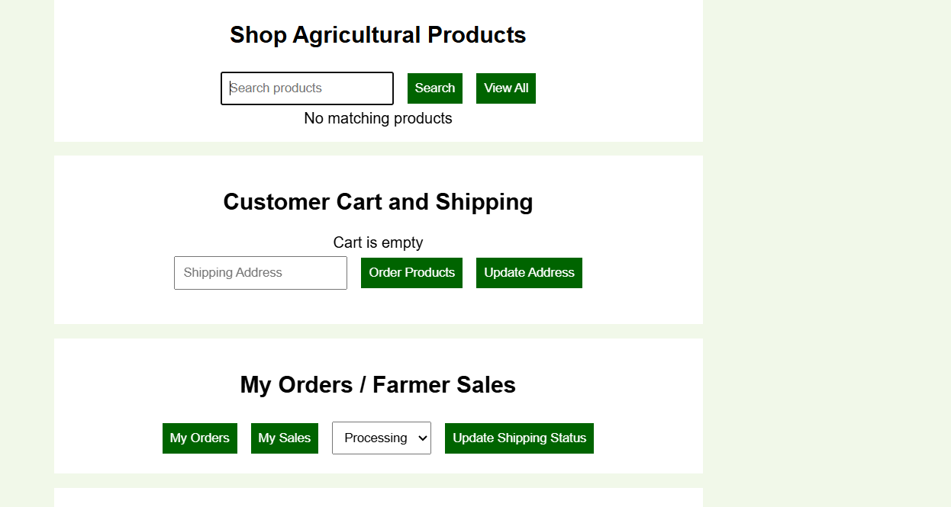

Result:
The AgriMart website was created with registration, farmer product management, product search, shopping cart, wallet, shipping address, orders, and shipping status.

